Mustang V-Labs - Instructions for macOS to Windows
Official URL: https://services.smsu.edu/TDClient/180/Portal/KB/Article/1061/Mustang-V-Labs-Instructions-for-macOS-to-Windows
Category: Knowledge Base > Information Technology Services > Software and Applications > Mustang V-Labs - Instructions for macOS to Windows
Tags: network, access, mac, mustangvlabs, remote, lab, vlab, os
_____________________________________________________
ATTENTION:
- Your username is: campus\YourStarID (i.e., smsu.edu\ab1234cd)
- Your password is: your StarID password
- Remember to log off and save your files to OneDrive or email them to yourself. Files saved directly on these computers will be deleted.
1. New users: Download the Windows app from the App Store. Search for "Windows App" and download the app.
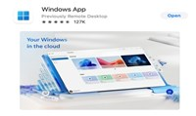
Figure 1: Uploaded Image (Thumbnail)
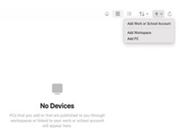
Figure 2: Uploaded Image (Thumbnail)
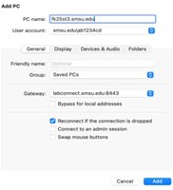
Figure 3: Uploaded Image (Thumbnail)
4. Once you've added the PC, click or type the link below in a new browser to connect to any of the available computers listed. Connect to any of the listed computers by clicking the "Connect" button to the right of desired computer: https://remoteaccess.labstats.com/Southwest-Minnesota-State-University
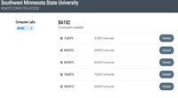
Figure 4: Uploaded Image (Thumbnail)
5. Clicking the "Connect" button for your desired computer prompts you to download and open the connection file, followed by the listed steps.
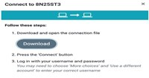
Figure 5: Uploaded Image (Thumbnail)
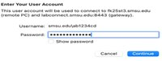
Figure 6: Uploaded Image (Thumbnail)
Click on Continue to gain access to the computer.
7. Always remember to log off the computer when you are finished using it.
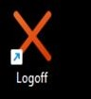
Figure 7: Uploaded Image (Thumbnail)
NOTE: For returning users, start from step 4
Accessibility Review & Update Log:
- [ ] Content accuracy verified
- [ ] Color contrast checked
- [x] Image alt-text verified (screenshots auto-captioned)
- [x] Document structure and headings formatted (perfect bold, list bulletpoints and sequences preserved)

